Safeguarding Level 3 – e-learning

If you have accessed e-learning for health before, you can use the same log-in, if not, you will first need to register/log-in following the link:
https://www.e-lfh.org.uk/

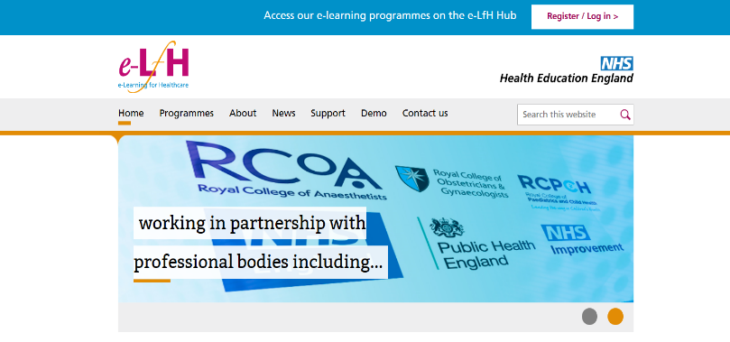
Follow the link to register/log-in which can be found in the top right hand corner of the page.

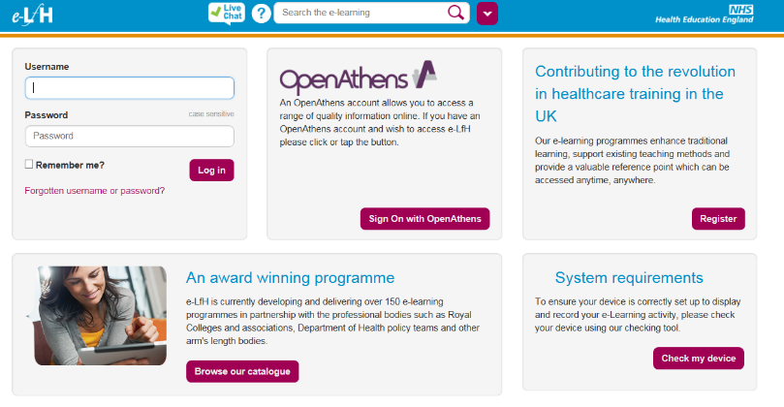
If you already have a log-in, complete your user-name and password and log-in as normal.

If you need to register, click on the register button.

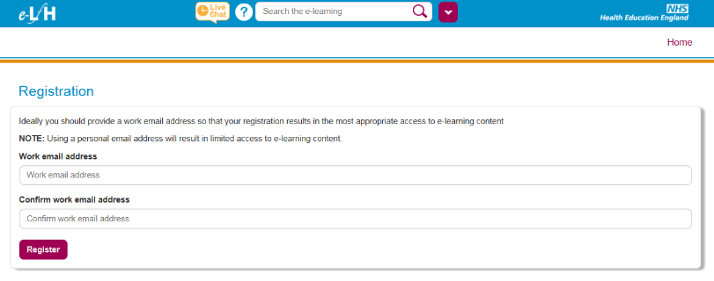
Complete the registration form as prompted using your work email address.

The next screen will ask you for your details, including which area of health you work in and where in the world you work. For the PRIMARY SPECIALITY option, you will need to select ‘other’ and for the section requesting the ODC code –you will need to type RYD into the box you will be given a choice of organisations in a pop-up box, scroll down until you find your station (or the closest one you can find).

Once you have logged in you will need to search for the safeguarding course by using the search facility found in the centre of the top bar. Typing in safeguarding will bring up a list of courses – select the course named Safeguarding Children and Young People (SGC). This will take you to all of the safeguarding child courses (levels 1-3) and you will need to enrol on the course named SGC Level 3 (2014) - Maintaining and Updating Competences (MaUC).

There are seven modules to complete before you finish the course and they are very hospital/paediatrician orientated – we are currently working on a bespoke SECAmb course. The modules vary in length, and this time requirement is outlined on the introductory page.

Once you have worked through all of the modules you will be able to print/screen-shot/save the certificate of completion. This must be shared with your OU administrator (list below) so they can update your training records.

Whilst this training is available to all patient facing staff, all registered health care staff MUST complete this training before the end of March 2018.

If you have completed Level 3 training (either as part of your continuous professional development, or because you work for another health trust) in the past 12 months and you can provide evidence of this to the OU administrators, you will not be expected to complete the course again.

If you have any problems in accessing this on-line course, please contact the safeguarding team via email safeguarding@secamb.nhs.uk

